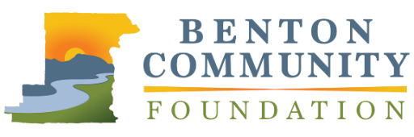
Outstanding Philanthropic Business

APPLICATION

The Benton Community Foundation Philanthropic Achievement Awards recognizes leadership in philanthropy and volunteerism. Outstanding Philanthropic Business will recognize a community-minded business that, through its foundation, grant-making and/or employee involvement, commits significant resources to assist local organizations in meeting community needs. Nominees who have contributed to charitable projects throughout Benton County and surrounding areas are eligible. Limit responses to 1,000 words total.

Nominations must be received by April 30, 2020, at 5:00 PM, via email to steven@bcfgives.org or mail to 660 NW Harrison Blvd., Corvallis, OR 97330. Recipients will be announced at the awards celebration in November 2020.

NOMINEE INFORMATION
Business Name |  |  | Name / Point of Contact
Street Address |  |  | Phone Number
City | State | Zip | Email
YOUR INFORMATION (if different from above)
Name |  |  | Email

Please describe the nominee and their philanthropic work in the community. Be sure to discuss the contributions they have made in terms of time and/or financial resources to support the causes they care about. Please also include the mission and vision of the nominee.

Please describe nominee’s commitment to improving the quality of life of Benton County residents through philanthropy, community involvement, and employee volunteerism. How has the business changed or improved because of the focus on employee volunteerism, philanthropy, and community involvement?

Describe how the nominee uses community involvement and philanthropy as an employee recruitment and retention tool, or how community involvement affects the work culture of the organization.

