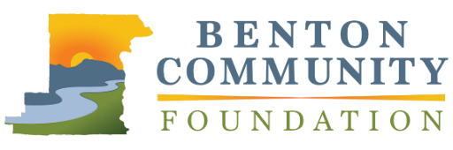
Outstanding Emerging Philanthropist

APPLICATION

The Benton Community Foundation Philanthropic Achievement Awards recognizes leadership in philanthropy and volunteerism. Outstanding Emerging Philanthropist will recognize an individual or group that has improved the community and increased opportunities for others through direct financial support, development of charitable programs, volunteerism, and/or philanthropic leadership. Nominees under the age of 30 who have contributed to charitable projects throughout Benton County and surrounding areas are eligible. Please limit responses to 1,000 words total.

Nominations must be received by April 30, 2020 at 5:00 PM, via email to steven@bcfgives.org or mail to 660 NW Harrison Blvd., Corvallis, OR 97330. Recipients will be announced at the awards celebration in November 2020.

NOMINEE INFORMATION
Name |  |  | Organization
Street Address |  |  | Phone Number
City | State | Zip | Email
YOUR INFORMATION (if different from above)
Name |  |  | Email

Please describe the nominee and their philanthropic work in the community. Be sure to discuss the contributions they have made in terms of time, talent, and/or financial resources to support the causes they care about.

Describe up to three projects the nominee has led or been involved in. What were the outcomes of these efforts? Please discuss the tangible impact these projects have made in the community.

Describe the nominee’s approach to leadership in philanthropy. Please tell us how they engaged or involved other youth or youth-led organizations.

