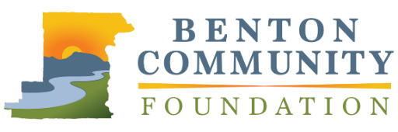
Outstanding Fundraising Professional

APPLICATION

The Benton Community Foundation Philanthropic Achievement Awards recognizes leadership in philanthropy and volunteerism. Outstanding Fundraising Professional will be awarded to a local development professional who has pursued ambitious ideas and successfully inspired and engaged others in philanthropy. Nominees who have contributed to charitable projects throughout Benton County and surrounding areas are eligible. Please limit responses to 1,000 words total.

Nominations must be received by April 28, 2021, at 5:00 PM, via email to steven@bcfgives.org or mail to 660 NW Harrison Blvd., Corvallis, OR 97330. Recipients will be announced at the awards event in November.

NOMINEE INFORMATION
Name |  |  | Organization
Street Address |  |  | Phone Number
City | State | Zip | Email
YOUR INFORMATION (if different from above)
Name |  |  | Email

Please describe the nominee and their fundraising work in the community. Be sure to discuss any contributions they have made to the development profession. What results does the nominee hope to achieve through their fundraising efforts?

Describe the nominee’s approach to leadership in fundraising. How has the nominee demonstrated leadership among their peers? This can include mentoring, involvement with professional organizations, or otherwise.

What is the most ambitious, impactful project the nominee has been involved in? What were the tangible outcomes of this project?

