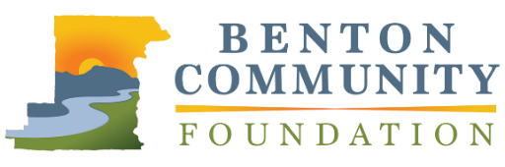
Outstanding Innovative Project or Program

APPLICATION

The Benton Community Foundation Philanthropic Achievement Awards will honor leadership in philanthropy and volunteerism. Outstanding Innovative Project or Program will recognize exceptional innovation and creativity in a recent charitable project. Innovation may be in terms of design, public involvement, and/or overall impact. Recent projects will have made measurable impact in the past five years. Nominees who have contributed to charitable projects throughout Benton County and surrounding areas are eligible. Limit responses to 1,000 words total.

Nominations must be received by April 28, 2021, at 5:00 PM, via email to steven@bcfgives.org or mail to 660 NW Harrison Blvd., Corvallis, OR 97330. Recipients will be announced at the awards event in November.

NOMINEE INFORMATION
Name |  |  | Organization
Street Address |  |  | Phone Number
City | State | Zip | Email
YOUR INFORMATION (if different from above)
Name |  |  | Email

Please describe the project or program. Who was involved, and what was the goal? What creative or innovative approach was implemented to address an ongoing challenge? What were the results?

What previous obstacles suggested that a new, innovative approach would be necessary? Describe the project and what makes it creative or unique. What innovative methods were used to engage donors, volunteers, or community members?

How did this project impact the local community? Please discuss the immediate and long-term effects of the project on the community.

