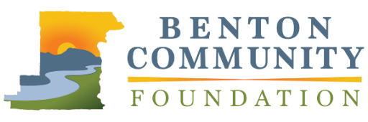
Outstanding Volunteer Group

APPLICATION

The Benton Community Foundation Philanthropic Achievement Awards recognizes leadership in philanthropy and volunteerism. Outstanding Volunteer Group will recognize a collective volunteer effort that has proven effective in moving community programs and projects forward. Nominees who have contributed to charitable projects throughout Benton County and surrounding areas are eligible. Limit responses to 1,000 words total.

Nominations must be received by April 28, 2021, at 5:00 PM, via email to steven@bcfgives.org or mail to 660 NW Harrison Blvd., Corvallis, OR 97330. Recipients will be announced at the awards event in November.

NOMINEE INFORMATION
Group Name |  |  | Name of Point of Contact
Street Address |  |  | Phone Number
City | State | Zip | Email
YOUR INFORMATION (if different from above)
Name |  |  | Email

Please describe the impact that the nominee is making in Benton County to improve the quality of life of Benton County residents.

Please describe the nominee and their philanthropic work in the community. Be sure to discuss the contributions they have made in terms of time volunteered, and/or dollars raised to support the causes they care about. Please also discuss any innovative ways the nominee has addressed community issues.

Describe the nominee’s approach to leadership in philanthropy. What are some ways they have inspired and encouraged others to give or become involved with the community?

How will the nominee’s volunteer and fundraising efforts be sustained in the future?

